SENTIMENT ANALYSIS USING RAPIDMINER – MOVIE REVIEWS
Sahil Patel, Drashti Khatra
INTRODUCTION-
The primary objective of this project is to develop an effective sentiment analysis model within the RapidMiner environment, utilizing various text processing techniques and machine learning algorithms. By comparing two distinct models with differing parameter settings, we aim to identify the configuration that yields the highest accuracy in classifying movie reviews as either positive or negative. Through this process, we seek to gain insights into the impact of parameter tuning on model performance and discuss the broader implications of sentiment analysis in marketing applications.
DATA DESCRIPTION-
The dataset employed in this project is derived from the Stanford Large Movie Review Dataset, which encompasses a total of 50,000 movie reviews, evenly distributed between 25,000 training and 25,000 testing examples. To maintain a balanced dataset for our analysis, we randomly selected 500 positive and 500 negative reviews from the training set, resulting in a curated collection of 1,000 labeled text files.
METHODOLOGY-

1. Data Processing:
Model 1 (Default Parameters):
- Utilized the 'Process Documents from Files' operator to read text files, with 'extract text only' and 'use file extension as type' options chosen. The encoding was set to 'System', and word vectors were created using TF-IDF. Pruning was set to percentual, with a lower bound of 3.0% and an upper bound of 30.0%.
- Applied 'Tokenize' operator with mode set to 'non-letters', 'Transform Cases' operator to convert tokens to lowercase, and 'Stem (Snowball)' operator with English language for stemming.
Model 2 (Optimized Parameters):
- Utilized the 'Process Documents from Files' operator to read text files, with similar settings as Model 1, except for pruning, which was set to absolute with a lower bound of 3.0 documents and an upper bound of 30.0 documents.
- Applied 'Tokenize' operator with mode set to 'linguistic tokens' and English language, 'Transform Cases' operator to convert tokens to lowercase, and 'Stem (Snowball)' operator with English language for stemming.
2. Data Splitting:
Implemented 'Cross Validation' operator with 10 folds, automatic sampling, and parallel execution enabled for both models.

3. Sentiment Classification Models:
Model 1 (Default Parameters):
Developed a k-NN model with k=5, weighted voting, and cosine similarity as the distance measure.
Model 2 (Optimized Parameters):
Developed a k-NN model with k=10, weighted voting, and Euclidean distance as the distance measure.
4. Performance Evaluation:
Model 1 (Default Parameters):
Assessed model performance using the 'Performance (Classification)' operator with accuracy as the main criterion, skipping undefined labels, and using example weights.
Model 2 (Optimized Parameters):
Assessed model performance using the 'Performance (Classification)' operator with accuracy as the main criterion, weighted mean recall and precision, skipping undefined labels, and using example weights.

EXPERIMENTAL RESULTS

Model 1: Default Parameters
The first model, which utilized default parameters, achieved an overall accuracy of 77.90% as evidenced by the confusion matrix. The confusion matrix provides a detailed breakdown of the model's performance:
- True Positives (TP): 406 correctly classified positive reviews
- True Negatives (TN): 373 correctly classified negative reviews
- False Positives (FP): 94 negative reviews incorrectly classified as positive
- False Negatives (FN): 127 positive reviews incorrectly classified as negative
The class precision for positive reviews was 76.17 %, indicating that out of all the reviews predicted as positive, 81.20% were actually positive.
For negative reviews, the class precision was 79.87 %, meaning that 74.60% of the reviews predicted as negative were truly negative.
Model 2: Optimized Parameters
The second model, which incorporated optimized parameters, demonstrated a significant improvement in accuracy, achieving 83.50% overall, as shown in the confusion matrix from the "Improved Parameters Result" PDF. Here's a detailed breakdown of Model 2's performance:
- True Positives (TP): 473 correctly classified positive reviews
- True Negatives (TN): 362 correctly classified negative reviews
- False Positives (FP): 138 negative reviews incorrectly classified as positive
- False Negatives (FN): 27 positive reviews incorrectly classified as negative
The class precision for positive reviews in Model 2 was 77.41%, indicating an improvement over Model 1. This means that out of all the reviews predicted as positive, 94.60% were indeed positive. The class recall for positive reviews was 94.60%, suggesting that Model 2 correctly identified a higher proportion of actual positive reviews compared to Model 1.
Regarding negative reviews, the class precision in Model 2 was 93.06%, showcasing an improvement from Model 1. This implies that 72.40% of the reviews predicted as negative were actually negative. The class recall for negative reviews was 72.40%, indicating that Model 2 accurately identified a lower percentage of actual negative reviews compared to Model 1.

COMPARISON AND ANALYSIS-
Comparing the results of the two models, it is evident that the optimized parameters in Model 2 led to a substantial improvement in overall accuracy, increasing from 77.90% to 83.50%. This enhancement can be attributed to the fine-tuning of key parameters such as the number of neighbors (k) and the distance measure used in the k-NN algorithm.
The class precision for positive reviews improved from 76.17% in Model 1 to 77.41% in Model 2, indicating that Model 2 made more accurate predictions for positive sentiment. However, the class recall for positive reviews saw a significant increase from 81.20% in Model 1 to 94.60% in Model 2, suggesting that Model 2 successfully identified a much larger proportion of the actual positive reviews.
Regarding negative reviews, the class precision improved from 79.87% in Model 1 to 93.06% in Model 2, demonstrating that Model 2 made more accurate predictions for negative sentiment. However, the class recall for negative reviews slightly decreased from 74.60% in Model 1 to 72.40% in Model 2, indicating that Model 2 missed identifying a small percentage of actual negative reviews compared to Model 1.
The reduction in false negatives from 127 in Model 1 to 27 in Model 2 is a notable improvement, as it minimizes the number of positive reviews incorrectly classified as negative. However, the number of false positives increased from 94 in Model 1 to 138 in Model 2, suggesting that Model 2 incorrectly classified more negative reviews as positive compared to Model 1.
Overall, the results demonstrate the importance of experimenting with different parameter settings to find the optimal configuration for a given dataset and problem. While Model 2 achieved a higher overall accuracy and significantly improved the recall for positive reviews, it also introduced a slight increase in false positives. This highlights the trade-off between precision and recall and the need to carefully consider the specific requirements and priorities of the sentiment analysis task when selecting the final model.

IMPLICATIONS FOR MARKETING

Text mining and sentiment analysis hold immense potential in the realm of marketing, empowering companies to efficiently process and derive insights from vast amounts of textual data. By gauging customer sentiment expressed in reviews, social media interactions, and other feedback channels, businesses can make data-driven decisions to enhance their products, services, and overall customer experience.
The sentiment classification models developed in this project exemplify the key steps involved in the text mining process:
1. Preprocessing the text data through tokenization, lowercasing, stopword removal, and stemming to normalize the content.
2. Extracting numerical features, such as TF-IDF vectors, to represent the text in a format suitable for machine learning algorithms.
3. Training a classification model on labeled data and fine-tuning its parameters to optimize performance.
4. Evaluating the model's accuracy using relevant metrics like precision, recall, and F1 score on a separate test set.
By leveraging sentiment analysis, marketers can gain valuable insights from customer feedback, enabling them to:
- Monitor brand sentiment trends over time
- Identify common issues and areas for improvement
- Detect emerging trends and opportunities
- Benchmark performance against competitors
- Personalize marketing messages and product offerings

CONCLUSION
This project showcases the development of a sentiment analysis model using RapidMiner, encompassing the entire process from text preprocessing to model evaluation. By comparing two models with varying parameter settings, we demonstrated the impact of parameter tuning on model performance. Model 2, with optimized parameters, achieved an overall accuracy of 83.50%, a substantial improvement over Model 1's accuracy of 77.90%.
The sentiment analysis techniques explored in this project have significant implications for marketing professionals. By leveraging text mining and sentiment analysis, businesses can efficiently analyze large volumes of unstructured text data, gaining valuable insights into customer sentiment. This enables them to make data-driven decisions, improve their products and services, and enhance overall customer satisfaction.
However, it is essential to recognize that the choice of model and parameter settings depends on the specific goals and priorities of the sentiment analysis task. While Model 2 achieved higher overall accuracy and recall for positive reviews, it also introduced a slight increase in false positives. Marketers should carefully consider the trade-offs between precision and recall, and select the model that best aligns with their objectives and the consequences of misclassifications.
In conclusion, sentiment analysis is a powerful tool for businesses to understand and respond to customer sentiment effectively. By continually refining and optimizing sentiment analysis models, marketers can unlock valuable insights from text data and make informed decisions to improve their marketing strategies and customer experience.

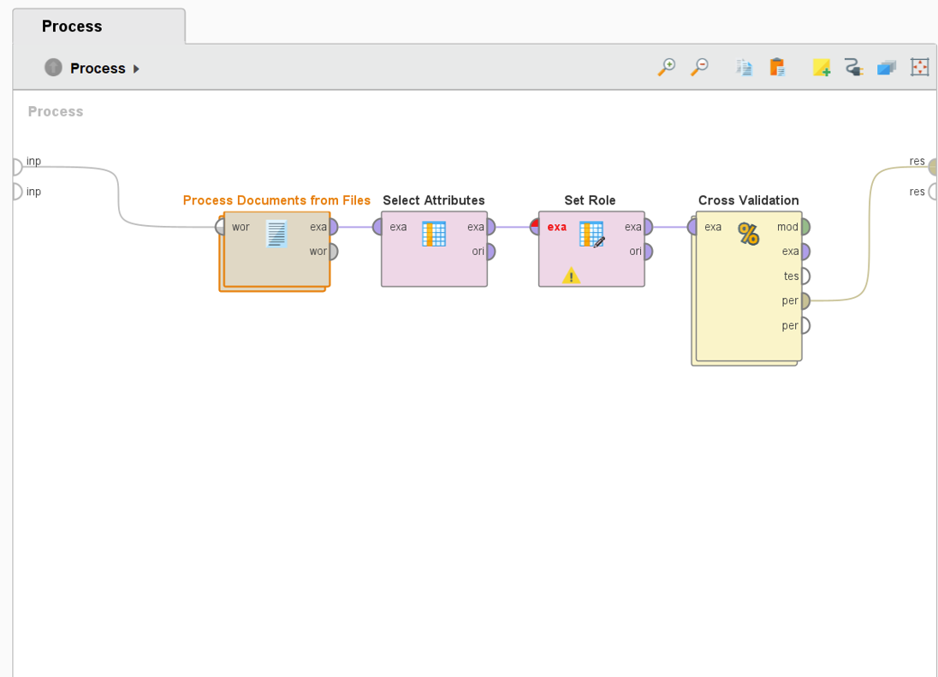

Model 1: Default Parameters
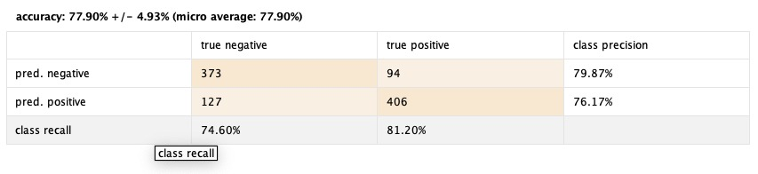

Model 2: Optimized Parameters
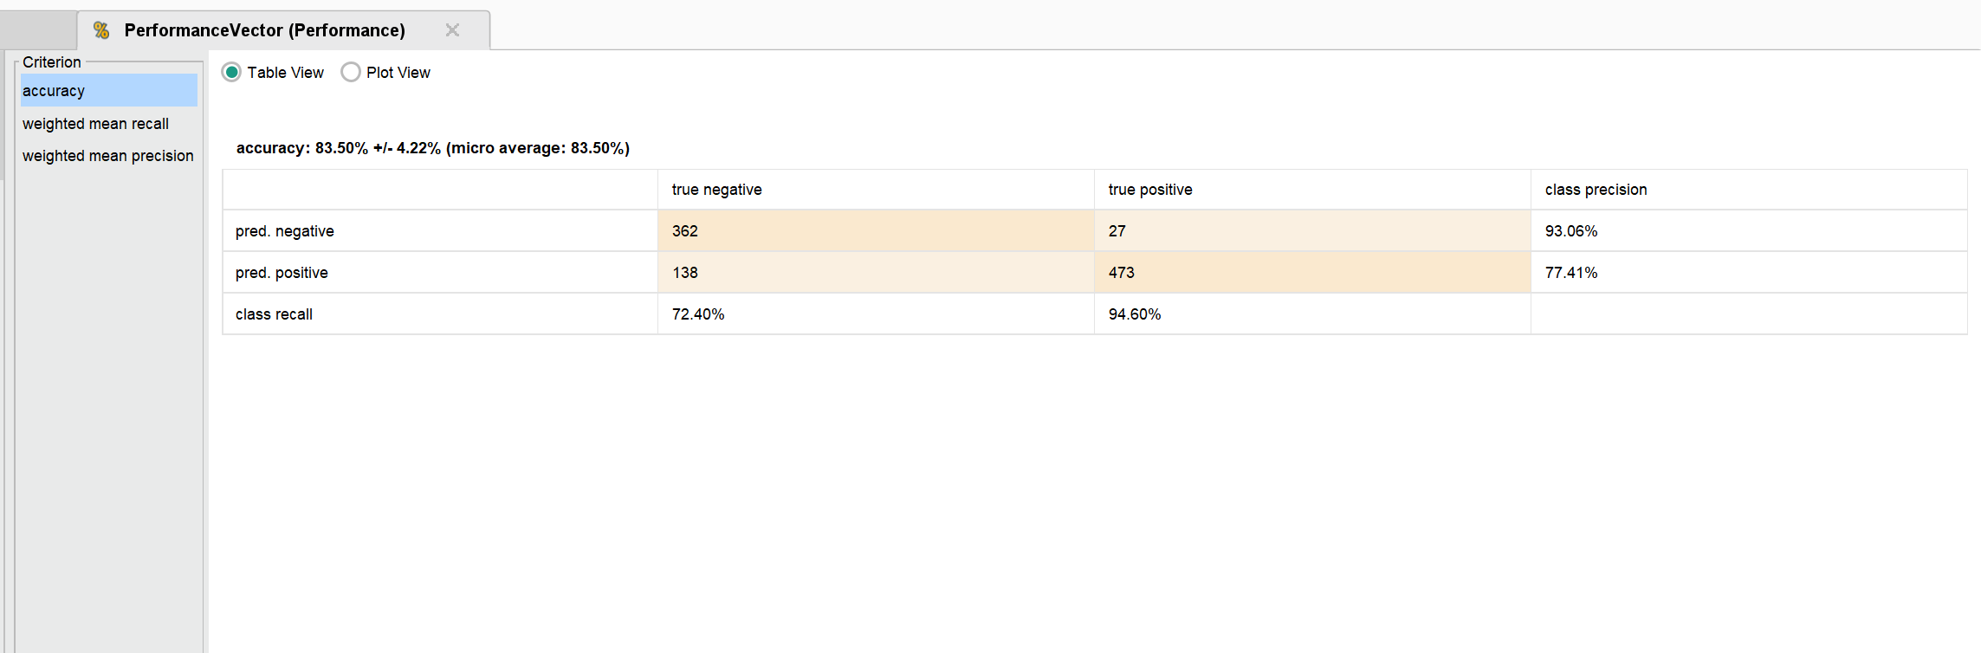

REFERENCES

Dataset- Maas, A. (n.d.). Sentiment Analysis. https://ai.stanford.edu/~amaas/data/sentiment/

